**WORK INSTRUCTIONS FOR DUST SAMPLING OF BF GAS**

**Criteria: Safe Dust sampling of BF gas**

**Responsibility: SS, Area Engineer In Charge**

**Identified Hazards:**

**Mechanical hazards**

1. Trapping between two objects
2. Fall of person
3. Fall of tools and tackles

**Chemical hazards**

1. CO gas poisoning

**Physical hazards**

1) Fire, explosion

2) Suffocation due to insufficient oxygen

3) Contact with hot water/Surface

**Human behavior**

1) Violation of procedure

2) Person working under alcohol

**Significant aspect:**

1. Fire & Explosion

**Procedure:**

1. Unauthorized operation or repair of any equipment is a punishable offence.
2. Seek the clearance from the SS and get work permit issued from the control room.
3. Activity should be carried out by utility in-change along with GCP/HBS operator.
4. Use 2 Nos. of CO monitor, 2 Nos. pressurized Air masks. utility in-charge and utility operator should ensure the CO level at the workplace and proper circulation of fresh air at the work place.
5. Carry out all operation as per work procedure SP 44.
6. Connect the gas sampler as per the below drawing.

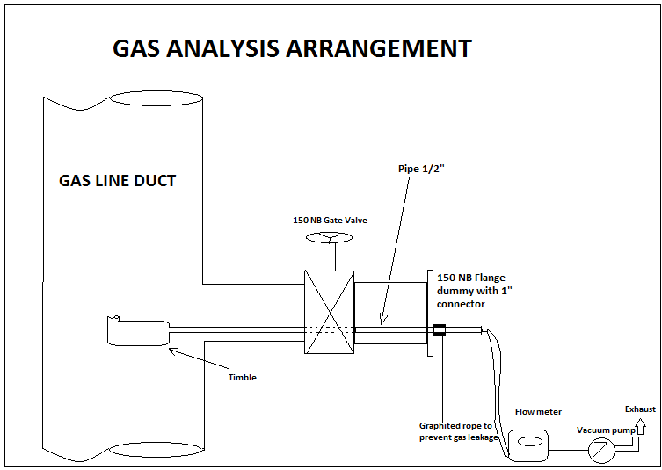

1. Persons operating the valve should wear air mask.
2. Use Pressurized air mask with compressed air while inserting Thimble.
3. Ensure a positive compressed air flow through mask. Regulate the flow to individual’s comfort level who is wearing.
4. Place the Thimble in 150 NB pipe through 150 NB flange dummy with 1” connector.
5. Care to be taken while inserting thimble inside the 150 NB flange dummy. (Ensure no leakage from 150NB valve).
6. Get clearance from Instrumentation and production before opening 150NB valve. Open Valve and insert the thimble as per requirement, till thimble reaches the center of gas line.
7. Ensure that nipple of the thimble is placed exactly opposite to the direction of the gas.
8. Collect the sample as per the requirement.
9. Remove the thimble by closing the valve (Ensure valve is fully closed and no gas leakage).
10. After removing thimble put dummy to the valve.

|  |  |  |
| --- | --- | --- |
| **Prepared By:**  Head – Production PID I | **Reviewed & Issued By:**  Management Representative | **Approved By:**  Head – Pig Iron Division |
| **Signature:** | **Signature:** | **Signature:** |
| **Date: 10.07.2023** | **Date: 10.07.2023** | **Date: 10.07.2023** |

|  |  |  |  |
| --- | --- | --- | --- |
| **Amendment Record** | | | |
| **Revision date** | **Manual Section ref. and para** | **Brief details of revision** | **New Revision No.** |
|  |  |  |  |
|  |  |  |  |